Behaviour Policy



The Croft Primary School

Written by: C.Wetton in consultation with staff
Date: November 2025
Review date: November 2026

We are caring, we are courageous, we are creative... We are The Croft.

Key principles
At the Croft Primary, we recognise that at the heart of our behaviour policy lies the positive and respectful relationships between staff and our pupils. It is essential that staff and pupils build trusting relationships where staff understand individual children’s needs and how best they respond. We recognise that a whole-school consistency approach to the positive management of behaviour is crucial and is the responsibility of all stakeholders. Ensuring that there is a clarity of high expectations where all pupils are able to learn in a positive, supportive and calm learning atmosphere.
This policy aims to:

- To encourage a calm, purposeful and happy atmosphere within the school.
- To foster positive caring attitudes towards everyone where achievements at all levels are acknowledged and valued.
- To encourage increasing independence, self-discipline and respect so that each child learns to accept responsibility for their own behaviour.
- To have a consistent approach to behaviour throughout the school with parental co-operation and involvement.
- To make boundaries of acceptable behaviour clear and to ensure safety.

Throughout the policy reference is made to supporting pupils in developing positive behaviours however we recognise that these high expectations should be consistently modelled by staff.

Our responsibilities with consistency in approach:
Pupils | All Staff | Senior leaders | Parents
To follow our school rules.  To try our best.  To show empathy towards others.  To take responsibility for our own actions.  To look after our school environment.  To act safely.  To be part of our school community. | Welcome pupils  Apply the school rules fairly and consistently  Model behaviours  Be calm and supportive  Never ignore inappropriate behaviour  Support in behaviour across the school  Plan appropriately pitched and engaging lessons | Be a visible presence including: start and end of day, breaktimes  Support staff in the fair application of policy  Liaise further with parents/carers  Share best practice  Monitor and evaluate  Support pupils with more complex behaviours | Support the school in the implementation of policy.  Foster good relationships with school.  Raise concerns with school and allow school to deal with these  Encourage independence, respect and self-discipline

Our School Rules

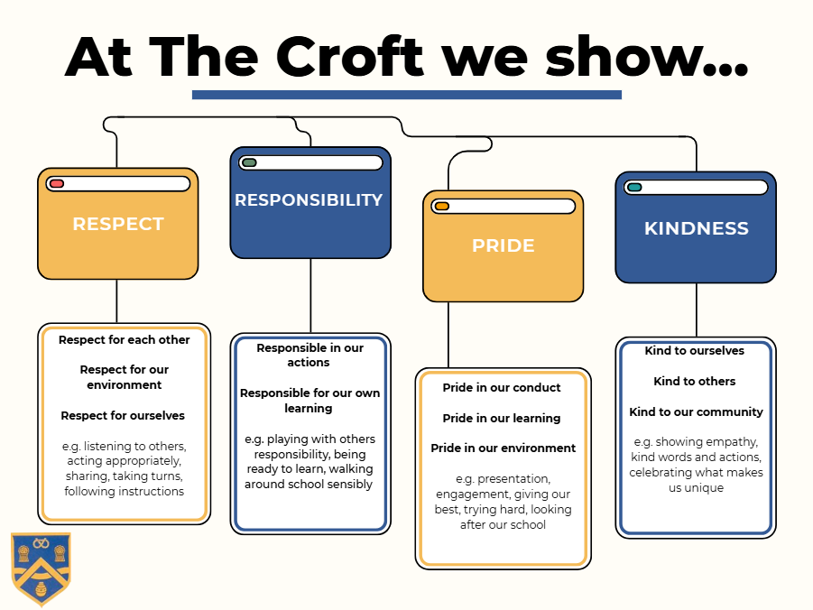

We understand at the Croft that we must actively teach these rules to support pupils in their behaviour and learning. We do this through a range of strategies...

- PSHE curriculum
- Assembly focuses
- Class assemblies with a targeted focus
- Nurture sessions
- 1 to 1 check ins
- Social stories
- Staff modelling clear and high expectations
- Focus of the week

We use a range of tiered strategies to support the positive recognition and reward for pupils following these school rules as well as sanctions for supporting the management of behaviour.
Whenever a sanction is used, staff are careful to ensure that this is in a calm and supportive manner.
These apply to all aspects of the school day and can be enforced by any member of staff.
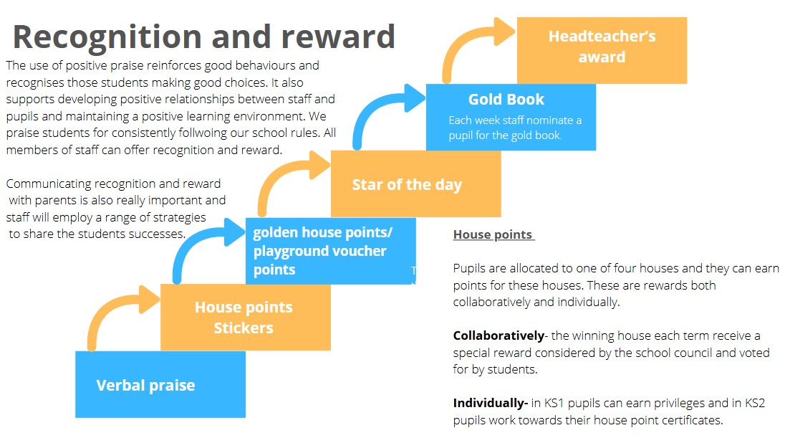
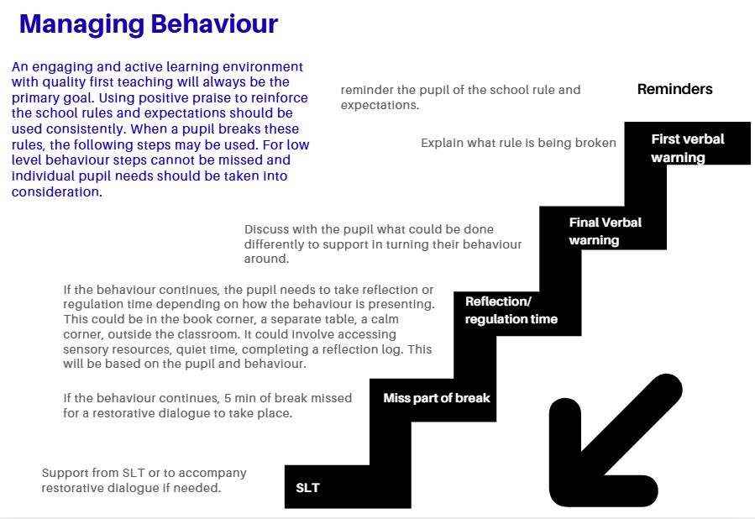
All above Sanctions REFRESH and RE-SET after EVERY break.

Consistent behaviour of concern
If a child is consistently breaking the school rules and the above sanctions have been exhausted, they will in agreement with SLT be put onto home-school report. This is a short-term intervention aimed at positively praising successes throughout the day but also ensuring effective restorative dialogues.
Parents will always be informed of this before it is implemented as it places a high value of the importance of the home-school relationship. The report will be shared with a member of SLT at three points a day and sent home each day for parents to see.

Serious incidents of behaviour
On occasion, behaviour may be of a more serious nature and need immediate intervention. In these incidents a ‘behaviour card’ will be issued. The pupil will need to miss 15min of the next break with a member of SLT and complete a reflection log. On these occasions, the child may be asked to work outside of the classroom for a period of time usually alongside a member of SLT.

These behaviours could include:
- Swearing
- Homophobic behaviours
- Racist behaviours
- Aggressive behaviours
- Persistent disruption to learning of others

These would be logged on our CPOMs system and patterns tracked and considered whether further intervention is required to support the child moving forwards.

Individualised needs (including SEND)
Some pupils behaviours or needs may present differently, in these situations an individual behaviour plan may be implemented and shared with parents. This may include triggers, what works best for the child and individualised rewards and sanctions. This will always be with the agreement of SLT and SENCO. Sometimes an individualised risk assessment may also be implemented.

At the Croft, we really value the support of early intervention and this could be through our own in school nurture sessions or through external referrals to agencies who can offer additional support such as the behaviour support team. Referrals to external agencies for this reason would usually require parental permission.

A pupil’s individual needs will always be considered on an individual basis to ensure that any reasonable adjustments are made to support them in managing their own behaviour.

After School Clubs
The expectations and routines outlined in the policy apply to afterschool clubs also. Pupils may have their place frozen if their behaviour is of a consistent unacceptable level.
Crafty Crofters have their own behaviour policy written carefully to match our whole school policy.

Physical restrictive intervention
The school has a statutory duty of care to ensure the safety and safeguarding of all pupils and staff. As a school, the use of physical restrictive intervention would only ever be used as a last resort and in-line with the DFE’s ‘Use of reasonable Force’ Guidance. This would only ever be to ensure the physical safety of pupils and/or staff when no-other intervention strategy is possible. The headteacher has physical restrictive intervention training from Dynamis. If physical restrictive intervention had been used, parents/carers would always be informed of this.

Suspensions and Exclusions

All suspensions and exclusions are carried out in line with DfE guidance - Suspension and permanent exclusion from maintained schools, academies and pupil referral units in England, including pupil movement (2024).

The Headteacher may use suspension and permanent exclusion as a sanction when warranted as part of creating calm, safe, and supportive environments where both pupils and staff can work in safety and are respected. Suspension and permanent exclusion are sometimes a necessary part of a functioning system, where pupil behaviour cannot be amended or remedied by pastoral processes, or consequences.

Any decision of the headteacher, including suspension or permanent exclusion, must be made in line with the principles of administrative law, i.e. that it is: lawful (with respect to the legislation relating directly to suspensions and permanent exclusions and a school’s wider legal duties); reasonable; fair; and proportionate.

Any suspension or exclusion is formally communicated to parents in writing clearly setting out the reasons for the suspension or exclusion. This is also shared with social worker, virtual school, governing board and local authority. The Headteacher will work with the local authority to arrange suitable fulltime alternative education for pupils receiving suspensions over five school day. When a pupils has been identified as at risk of suspension or exclusion or has received a suspension, the school will, with parents consent, refer the child to the SEN and Inclusion hub and adopt a multi agency approach where necessary

Preventative measures to avoid exclusion

In addition to initial intervention, the school will also consider: Off-site time-limited direction to alternative provision and/or Managed moves.

Suspension

A suspension, where a pupil is temporarily removed from the school, is an essential behaviour management tool. A pupil may be suspended for one or more fixed periods (up to a maximum of 45 school days in a single academic year). A suspension does not have to be for a continuous period.

A suspension may be used to provide a clear signal of what is unacceptable behaviour as part of the school’s behaviour policy and show a pupil that their current behaviour is putting them at risk of permanent exclusion.

During a suspension, pupils still receive their education. The school will set and mark work for pupils during the first five school days of a suspension. Where suspensions are becoming a regular occurrence for a pupil, the headteacher will consider whether suspension alone is an effective sanction for the pupil and whether additional strategies need to be put in place to address behaviour.

Permanent exclusion

A permanent exclusion is when a pupil is no longer allowed to attend a school (unless the pupil is reinstated). The decision to exclude a pupil permanently should only be taken: in response to a serious breach or persistent breaches of the school's behaviour policy; and where allowing the pupil to remain in school would seriously harm the education or welfare of the pupil or others such as staff or pupils in the school. The school will set and mark work for pupils during the first five school days of an exclusion.

Reasons for Suspension or exclusion

The Headteacher will use their professional judgement based on the individual circumstances of the case when considering whether to suspend or exclude a pupils. The reasons below are examples of the types of circumstances that may warrant a suspension or permanent exclusion.
• Physical assault against a pupil
• Physical assault against an adult
• Verbal abuse or threatening behaviour against a pupil
• Verbal abuse or threatening behaviour against an adult
• Use, or threat of use, of an offensive weapon or prohibited item that has been prohibited by a school’s behaviour policy
• Bullying
• Racist abuse
• Abuse against sexual orientation or gender reassignment
• Abuse relating to disability
This list is not exhaustive and is intended to offer examples rather than be complete or definitive.

Reintegration following a suspension

After a suspension (or cancelled exclusion), parents and pupils will be requested to attend a reintegration meeting. This meeting and processes that are agreed within the meeting offers the pupil a fresh start; helps them understand the effect of their behaviour on themselves and others; teaches them how to meet the high expectations of behaviour in line with the school culture; fosters a renewed sense of belonging within the school community; and builds engagement with learning. Strategies for reintegration may include, but are not limited to:
- Maintaining regular contact during the suspension or off-site direction and welcoming the pupil back to school
- Implementation of a behaviour plan and/or risk assessment if not already in place
- Daily check-ins in school;
- Use of a report card and/or personalised reward system
- Planned pastoral interventions
- Mentoring by a trusted adult
- Regular reviews with the pupil and parents to praise progress being made and address any concerns at an early stage
- Informing the pupil, parents and staff of potential external support

The governing Board’s duty to consider an exclusion

Any suspension or exclusion is formally communicated in writing to parents. This letter also explains the parent’s right of representation to the governing board. The governing board has a duty to consider parents’ representations about a suspension or permanent exclusion. The requirements on a governing board to consider the reinstatement of a suspended or permanently excluded pupil depend upon a number of factors. The governing board must consider and decide on the reinstatement of a suspended or permanently excluded pupil within 15 school days of receiving notice of a suspension or permanent exclusion from the headteacher if:
• it is a permanent exclusion;
• it is a suspension which would bring the pupil's total number of school days out of school to more than 15 in a term;
• it would result in the pupil missing a public examination or national curriculum test

Where a pupil would be excluded for more than five but not more than 15 school days in a term, if the parents make representations, the governing board must consider and decide within 50 school days of receiving the notice of suspension whether the suspended pupil should be reinstated. In the absence of any representations from the parents, the governing board is not required to meet and cannot direct the reinstatement of the pupil. In the case of a suspension which does not bring the pupil's total number of days of suspension to more than five in a term, the governing board must consider any representations made by parents, but it cannot direct reinstatement and is not required to arrange a meeting with parents. Part 7 of Dfe Suspension and permanent exclusion guidance give guidance for the governing body.

Banned items

The Headteacher and senior leadership team have a statutory power to search a pupil, or their possessions, where they have reasonable grounds to suspect that the pupil may have a prohibited item The list of prohibited items is:
• knives and weapons;
• alcohol;
• illegal drugs;
• stolen items;
• any article that the member of staff reasonably suspects has been, or is likely to be used:
• to commit an offence, or
• to cause personal injury to, or damage to property of; any person (including the pupil). • an article specified in regulations: 12
• tobacco and cigarette papers;
• fireworks; and
• pornographic images.
Being in possession of a prohibited item – especially knives, weapons, illegal drugs or stolen items – may mean that the pupil is involved, or at risk of being involved, in anti-social or criminal behaviour including gang involvement, and in some cases may be involved in child criminal exploitation. A search may play a vital role in identifying pupils who may benefit from early help or a referral to the local authority children’s social care services. Details for how a search would be carried out can be found here.

Behaviour outside of school

In some circumstances the school may provide sanctions for pupils for inappropriate behaviour outside of school that has been witnessed by a member of staff or reported to school. This would be through liaising with parents/carers.

Conduct outside the school premises that may result in sanction includes behaviours:
• when taking part in any school-organised or school-related activity;
• when travelling to or from school;
• when wearing school uniform;
• that poses a threat to another pupil; or
• that could adversely affect the reputation of the school.

Child on Child Abuse

Following any report of child-on-child abuse offline or online, the school follows the safeguarding principles set out in Keeping Children Safe in Education (KCSIE) - especially Part 5. These are outlined clearly in the Child on Child Abuse Policy. The designated safeguarding lead (or deputy) is the most appropriate person to advise on the school’s initial response. Each incident should be considered on a case-by-case basis.

Safeguarding

Staff always consider whether the misbehaviour gives cause to suspect that a pupil is suffering, or is likely to suffer, harm. Where this may be the case as set out in Part 1 of Keeping Children Safe in Education, school staff follow the child protection policy and speak to the designated safeguarding lead (or deputy). They will consider if pastoral support, an early help intervention or a referral to children’s social care is appropriate

Associated policies

- Antibullying Policy
- Equality Policy
- P.S.H.E. Policy
- Online Safety Policy
- Acceptable use Agreement
- Safeguarding Policy
- Child on Child Abuse Policy
- Complaints and compliments policy

